Value and Debt
Richard P. Rumelt

The direct approach to valuation is to forecast the future expected levels of free cash flow (FCF) and then to discount these values at the weighted average cost of capital. However, in many cases we prefer to work with a model in which the choice of a few parameters implies the whole future pattern of cash flows. We shall describe several examples, ranging from the simple to the complex.
The advantages of debt are that interest payments are tax deductable and that debt investors have no claims on excess earnings unless interest payments are missed. In standard valuation methods, the corporation's leverage is taken as a given. That leverage, normally defined as the market value of debt to sum of the market values of debt and equity, influences the riskiness of the earnings available to equity investors and future tax payments. In particular, if one uses the CAPM, then the measured beta of a firm is
where the leverage with both debt D and equity E measured at market values.
One can estimate the impact of changes in leverage using the weighted-average cost of capital approach. However, in general it is better to use the adjusted present value model to do this. The APV makes it easier to include effects such as the expected cost of bankruptcy.
The APV estimates the value of a firm as three components: the value of the unlevered firm, the value of the tax-saving due to debt, and the expected cost of defaulting on debt payments.
An APV valuation proceeds in these steps:
- The value of the unlevered enterprise is computed. This can be done in two basic ways:
  - Use the unlevered beta to compute an unlevered cost of capital and value the free cash flows using this cost of capital.
  - Start with the current market value of the firm and subtract the net benefits of debt. The net benefits of debt (see below) are the tax shield of debt reduced by the expected costs of a default restructuring.
- The value of the tax benefits of debt are estimated.
- The probability p of default is estimated and the cost of a default is estimated.
The sum of these elements gives the value of the levered enterprise. In the simplest case, we estimate the tax shield from debt as TD, where T is the marginal tax rate and D is the amount of debt. This figure is obtained even if debt grows over time because we discount future tax savings at the cost of debt, cancelling out the effects of growth. With this assumption, the APV gives
Importantly, the value V is the value of the operating assets—the total value of the business. To obtain the value of the equity it is necessary to subtract the market value of debt and add back in the value of excess cash.
To estimate default probabilities, we can use Altman's analysis of data from the ratings companies as shown below. It links bond ratings to annual and cumulative default probabilities over 10 years.
Exhibit 1—Bond Default Data
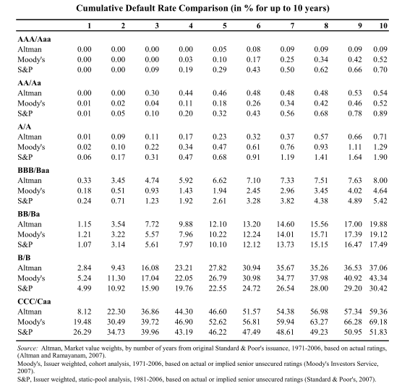
Estimating the cost of default requires much more hand-waving. Emprical studies place it in the range of 5-20% of the firm's unlevered "value." Fifteen percent is a good place to start.
The third link in the logic of debt are the relationships between default risk, ratings, and interest rates. The ratings agencies use a number of factors in assessing risk, but the most important one is interest coverage. That is the ratio of EBIT to interest expense (having adjusted interest to reflect the interest on the implied debt of long-term leases.)
Aswath Damodaran (Stern School, NYU) provides these useful (and current as of 2009) tables relating interest coverage ratios to bond ratings and interest spreads (interest rates above long-term Treasury rates).

Exhibit 2
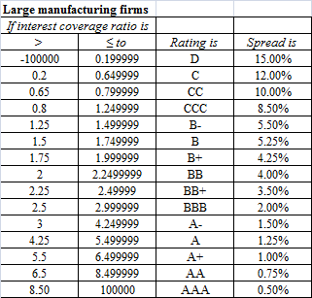
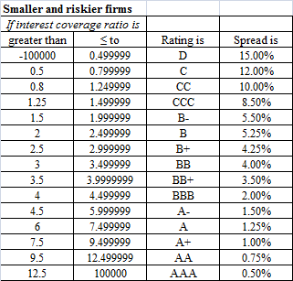

Exhibit 2 continued
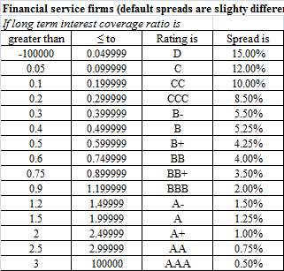

For up-to-date data on ratings and spreads you can visit www.bondsonline.com and search on "spreads."
Using this data to estimate a "rating" on a new level of debt involves (a) estimating the interest rate, (b) using that rate times the amount of debt to estimate interest payments, (c) dividing those payments into EBIT to get the coverage ratio, and then (d) using the coverage ratio to estimate the bond rating and the spread. This spread, added to the risk-free rate, gives the interest rate. If your initial guess was far off, you need to go around the loop again until the rate used to calculate coverage is close to the rate implied by the virtual rating.
Given the bond rating, you can back out a probability of default and then estimate the expected cost of default.
(A detail that must be taken into account if you want to have an accurate analysis of very high levels of debt is that the tax shield begins to disappear as interest expenses exceed EBIT.)

Valuation Models. ©2010 Richard P. Rumelt. This work is licensed under a Creative Commons Attribution NonCommercial 4.0 International License (CC BY-NC 4.0). You may copy, distribute, and adapt this material for non-commercial purposes, provided appropriate credit is given. Commercial use requires written permission from the author.

